**British Association of Dermatologists, Dermatology and Genetic Medicine (BADGEM)**

(from Kenny Morrison and Duncan Heather on behalf of Irene Leigh)

**Patient**

[Id]

[Forename]

[Surname]

[Address]

[ClinicianId]

[ConsentObtained]

[Diagnosis]

[Mutation]

[OtherComments]

[Gender]

[DateOfBirth]

[ChiNumber]

[NhsNumber]

[Relatives]

[Site]

**Gene**

[PatientId]

[Gene]

[Result]

[AdditionalText]

**User**

[Id]

[Username]

[Title]

[Specialisation]

[Forename]

[Surname]

[Affiliation]

[TypeOfUser]

[Site]

**Minimal essential dataset EB-registry Freiburg**

(from Cristina Has)

1. Patient’s name and surname, date of birth, date of death (if applicable), gender
2. Patient’s address and phone
3. Referring physician with address and phone
4. EB type and subtype (according to Fine et al, J Am Acad Derm 2014)
5. Immunofluorescence mapping / electron microscopy result
6. Mutation analysis result

**French EB Registry**

(from Alain Hovnanian’s laboratory)

INSERM UMR 1163, Laboratory of Genetic skin diseases

IMAGINEInstitutefor Genetic Diseases

**Minimal data set:**

Family name

First name

Date of birth

Gender

EB type and subtype

Referent clinician

City and country of residence

Geographic origin of ancestors

We also have comprehensive information on :

Clinical features

Biological features

Mutated gene and mutations

*(In fact we have identified the vast majority of these muations in my laboratory since 1993)*

Consanguinity

Immunostaining results

Electron microscopy results

Biological material

**EB House Austria**

Gabi Pohla Gubo and Helmut Hintner

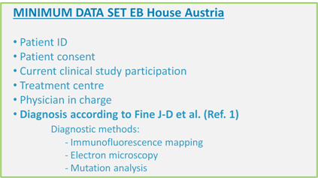

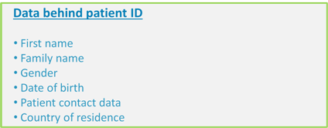

**Birmingham EB database**

from Celia Moss

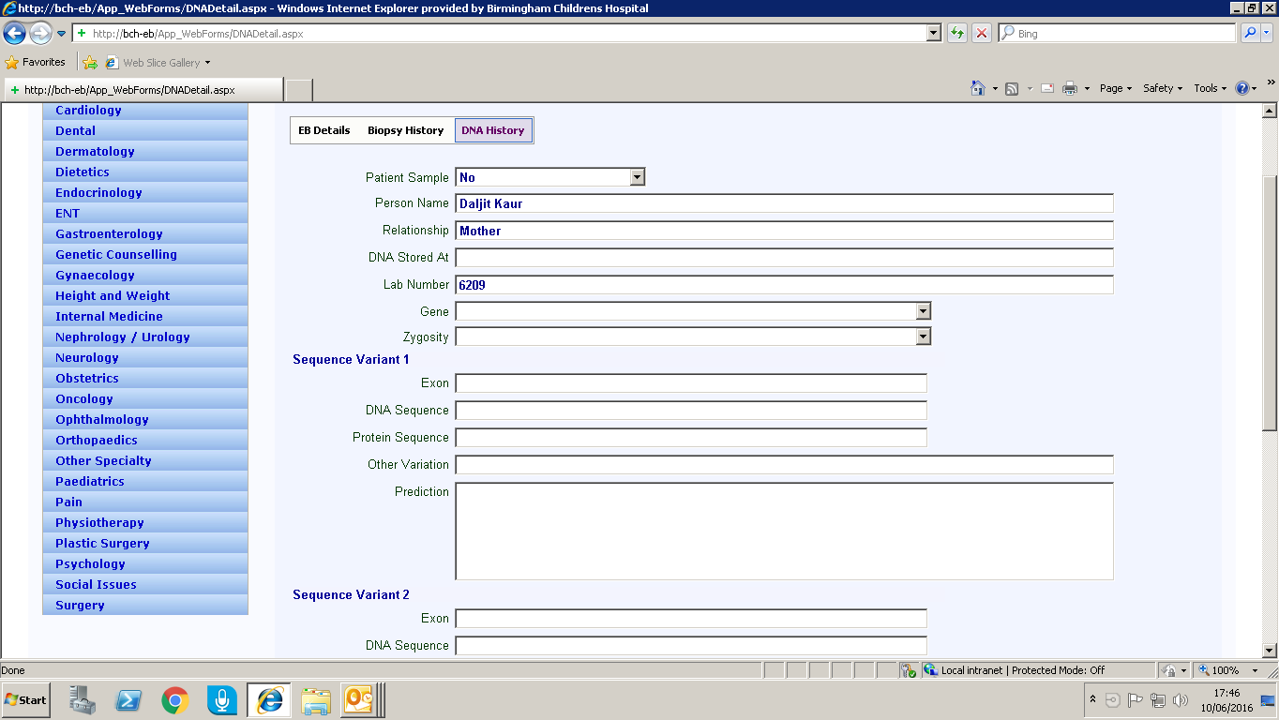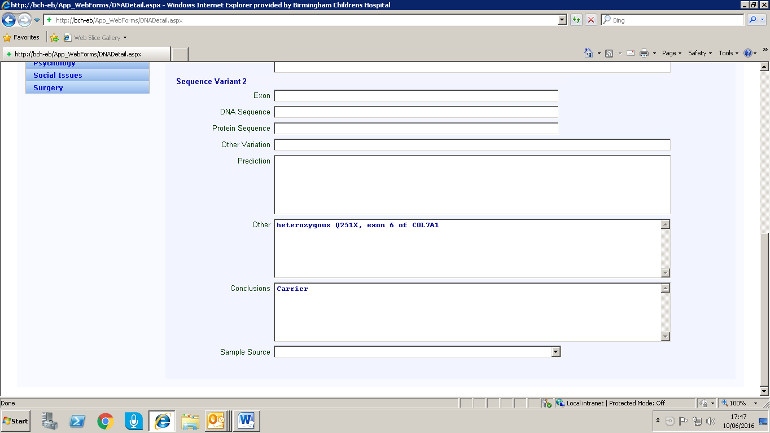

**Common Data Elements (CDE) and Specific Data Elements (SDE) of the French Minimum Data Set**

(from Christine Bodamer)

|  |  |  |  |  |  |
| --- | --- | --- | --- | --- | --- |
| Common | Data Element | Data Element Definition | FHIR Resource and | Domain Value (data type or | GRDR |
| or |  |  | element (extension?) | codeable concept with an | alignment (Data |
| Specific |  |  |  | external coding resource) | element and/or |
| Data |  |  |  |  | Value domain |
| Element |  |  |  |  | levels, Total or |
|  |  |  |  |  | Partial) |

**Patient resource -** Demographics and other administrative information about a person or animal receiving care or other health-related

services.

|  |  |  |  |  |  |
| --- | --- | --- | --- | --- | --- |
| CDE | Patient consent | Does the patient give his/her consent for information to be stored in a computer data management system? | Patient.consent (ext) | boolean | DEL: total VDL: total |
| CDE | Patient non- | Has the patient been informed | Patient.nonOpp (ext) | boolean |  |
|  | opposition for the reuse of data | for a future re-use of his/her de-identified data for other |  |  | DEL: - |
|  |  | research purposes? |  |  | VDL: - |
| CDE | Consent by legal | Is the consent given by the | Patient.tutorConsent (ext) | boolean | DEL: total |
|  | guardian | patient's legal guardian? |  |  | VDL: |
|  |  |  |  |  | deductible |
| CDE | National rare | GUID (Global Unique | Patient.identifier | string |  |
|  | disease identifier | Identifier) allowing the unique |  |  |  |
|  |  | identification of patients between BaMaRa and |  |  | DEL: - |
|  |  | BNDMR (de-identified). |  |  | VDL: - |
| CDE | Health national | Patient identifier subject to the | Patient.identifier | string |  |
|  | identifier | discretion of the CNIL: unique |  |  |  |
|  |  | national identifier allowing |  |  |  |
|  |  | future connections with the French personal national |  |  | DEL: - |
|  |  | medical record |  |  | VDL: - |
| CDE | Local patient | Identifier of the patient in the | Patient.identifier | string | DEL: |
|  | identifier | hospital. |  |  | deductible |
|  |  |  |  |  | VDL: total |
| CDE | Patient's patronymic name | Patient's patronymic name (surname at birth). | Patient.name.family | string | DEL: total |
|  | (surname at birth) |  |  |  | VDL: total |
| CDE | Patient's (usual) | Patient's (usual) last name. | Patient.name.family | string | DEL: - |
|  | last name |  |  |  | VDL: - |
| CDE | Patient's first name | Patient's first name as specified on the birth | Patient.name.given | string | DEL: total |
|  |  | certificate or identity card. |  |  | VDL: total |
| CDE | Date of birth of the patient | Patient's date of birth as recorded on the birth | Patient.birthdate | dateTime | DEL: total |
|  |  | certificate. |  |  | VDL: total |
| CDE | Gender | Patient's gender. | Patient.gender | F-female |  |
|  |  |  |  | M-male  UN-undifferentiated | DEL: total |
|  |  |  |  | UNK-unknown | VDL: partial |
| CDE | Fœtus (if | Whether information is | Patient.fœtus (ext) | boolean | DEL: - |

|  |  |  |  |  |  |  |
| --- | --- | --- | --- | --- | --- | --- |
|  | applicable) | recorded for a foetus. |  |  | VDL: - | |
| CDE | City of birth | Patient's city of birth. | Patient.birthCity (ext) | INSEE city code | DEL: total | |
|  |  |  |  |  | VDL: total | |
| CDE | Country of birth | Patient's country of birth. | Patient.birthCountry (ext) | ISO code 3166-1 alpha-2 | DEL: total | |
|  |  |  |  |  | VDL: total | |
| CDE | City de residence | Patient's city of residence. | Patient.address.city | INSEE city code | DEL: total | |
|  |  |  |  |  | VDL: total | |
| CDE | Country of | Patient's country of residence. | Patient.address.country | ISO code 3166-1 alpha-2 | DEL: total | |
|  | residence |  |  |  | VDL: total | |
| CDE | Vital status of the | Is the patient deceased? | Patient.deceasedBoolean | boolean | | DEL: total |
|  | patient |  |  |  | | VDL: total |
| CDE | Patient's date of | Patient's date of death | Patient.deceasedDatetime | dateTime | | DEL: total |
|  | death |  |  |  | | VDL: partial |
| CDE | Death due to the rare disease | Is death due to the rare disease the patient is suffering from? | Patient.deceasedRD (ext) | Y-yes N-no | | DEL: - |
|  |  |  |  | UNK-unknown | | VDL: - |
| CDE | If death is not | If death is not due to the rare | Patient.deceasedCause | ICD10 | |  |
|  | linked to a rare disease, the main | disease, what is the main cause of death? | (ext) |  | | DEL: - |
|  | cause of death |  |  |  | | VDL: - |
| SDE | Patient addressed | The patient may have been | Patient.sentBy (ext) | VLM-come by himself | |  |
|  | by | referred to the RD center by a |  | ASS-patient association | |  |
|  |  | health care professional. This |  | GNR-generalist | |  |
|  |  | assesses the attractiveness of |  | PEV-paediatrician (non | |  |
|  |  | the RD reference center for |  | hospital practice) | |  |
|  |  | professionals. |  | PEH-paediatrician (hospital | |  |
|  |  |  |  | practice) | |  |
|  |  |  |  | PMI-center of maternal and | |  |
|  |  |  |  | child health | |  |
|  |  |  |  | GEN-geneticist | |  |
|  |  |  |  | GYO- | |  |
|  |  |  |  | gynecologist/obstetrician | |  |
|  |  |  |  | SPE-other specialist | |  |
|  |  |  |  | CPC-center of support | |  |
|  |  |  |  | CPD-multidisciplinary center | |  |
|  |  |  |  | of prenatal diagnosis | |  |
|  |  |  |  | CDP-center of prenatal screening | | DEL: - |
|  |  |  |  | A-other | | VDL: - |
| SDE | Patient's date of inclusion in the | Date at which the patient was recorded in the RDC. | Patient.inclusionDate (ext) | dateTime | | DEL: - |
|  | RD center |  |  |  | | VDL: - |
| SDE | Name of in charge doctor | Name of the physician in charge of the patient in the | Patient.careProvider | resource (practitioner) | | DEL: - |
|  |  | current care unit |  |  | | VDL: - |

**Family History resource -** Significant health events and conditions for people related to the subject relevant in the context of care for the

subject.

# CDE Propositus First patient recorded in a rare

disease center for a given family.

FamilyHistory.propositus

(ext)

boolean DEL: -

VDL: -

CDE Relationship with

the propositus

Describes the relationship

between a patient of the family

FamilyHistory.relation <http://hl7.org/fhir/v3/RoleCode> DEL: -

and the propositus. VDL: -

|  |  |  |  |  |  |
| --- | --- | --- | --- | --- | --- |
| CDE | Patient born from | Is the patient born from a | FamilyHistory.inbreeding | Y-yes |  |
|  | a relationship between related | relationship between related parties? | (ext) | N-no  UNK-unknown | DEL: - |
|  | parties |  |  |  | VDL: - |

**Encounter resource -** An interaction between a patient and healthcare provider(s) for the purpose of providing healthcare service(s) or

assessing the health status of a patient.

|  |  |  |  |  |  |
| --- | --- | --- | --- | --- | --- |
|  | Sequential ID |  | Encounter.identifier |  | |
| SDE | Date of care performed for the | Date at which the declared patient care was performed. | Encounter.period.start | dateTime | DEL: - |
|  | patient |  |  |  | VDL: - |
| SDE | Context of the | Context indicating the type of | Encounter.type | CON-consultation |  |
|  | care activity | care performed. (Useful infor- |  | CPD-multidisciplinary |  |
|  |  | mation for the RD reference |  | consultation |  |
|  |  | center annual report). |  | HDJ-day hospital |  |
|  |  |  |  | HTR-traditional hospital |  |
|  |  |  |  | ASD-advice on medical record |  |
|  |  |  |  | during consultation |  |
|  |  |  |  | EXP-expert advice on medical |  |
|  |  |  |  | record |  |
|  |  |  |  | AES-advice given in another |  |
|  |  |  |  | ward  TLC-teleconsultation | DEL: - |
|  |  |  |  | A-other context | VDL: - |
| SDE | Objectives of the | Objectives of the declared care | Encounter.objective (ext) | DIA-diagnosis |  |
|  | care activity | activity. |  | PEC-implementation of |  |
|  |  |  |  | support |  |
|  |  |  |  | SUI-follow up |  |
|  |  |  |  | CGE-genetic counselling |  |
|  |  |  |  | DPR-prenatal diagnosis |  |
|  |  |  |  | DPI-preimplantation |  |
|  |  |  |  | URG-emergency support ACT-medical act | DEL: - |
|  |  |  |  | PRO-research protocol | VDL: - |
| SDE | Occupation of the | Type of personnel performing | Encounter.participantProf | ASS-social worker |  |
|  | personnel | the declared activity. | ession (ext) | DIE-dietician |  |
|  | performing the |  |  | ERG-occupational therapist |  |
|  | care activity |  |  | KIN-physiotherapist |  |
|  |  |  |  | PSY-psychologist |  |
|  |  |  |  | PSM-physical therapist |  |
|  |  |  |  | CEG-genetic counsellor |  |
|  |  |  |  | INF-nurse |  |
|  |  |  |  | ORT-speech therapist |  |
|  |  |  |  | ESP-specialist teacher MED-physician | DEL: - |
|  |  |  |  | A-other professional | VDL: - |
| SDE | Personnel performing the | Name of the professional performing the activity. | Encounter.participant.indi vidual | resource (practitioner) | DEL: - |
|  | activity |  |  |  | VDL: - |

**Condition resource -** Used to record detailed information about conditions, problems or diagnoses recognized by a clinician. There are many

uses including: recording a Diagnosis during an Encounter; populating a problem List or a Summary Statement, such as a Discharge Summary.

Diagnosis history

|  |  |  |  |  |  |
| --- | --- | --- | --- | --- | --- |
| CDE | Age at onset | Age at which symptoms first | Condition.firstSignsOcc | ANA-antenatal | DEL: total |
|  |  | appeared? | (ext) | NAI-at birth  PNA-postnatal | VDL: |
|  |  |  |  | UNK-undetermined | partial/deductible |
| CDE | Age at onset | Age at which symptoms first | Condition.ageSigns (ext) | integer |  |

# DEL:

|  |  |  |  |  |  |
| --- | --- | --- | --- | --- | --- |
|  | (months) | appeared? |  |  | deductible  VDL: |
|  |  |  |  | deductible |
| SDE | Assessment of the diagnosis at center | Was patient's diagnosis appropriate when admitted to | Condition.earlyDiagnosis Satus (ext) | ABS-missing  NAP-inappropriate | DEL: - |
|  | admission | the RD center? |  | APP-appropriate | VDL: - |
| CDE | Age at diagnosis | Age at diagnosis? | Condition.onset (ext) | ANA-antenatal NAI-at birth | DEL: total |
|  |  |  |  | PNA-postnatal | VDL: |
|  |  |  |  | UNK-undetermined | partial/deductible |
| CDE | Age at diagnosis | Age at diagnosis? | Condition.onsetAge | integer | DEL: |
|  | (months) |  |  |  | deductible |
|  |  |  |  |  | VDL: |
|  |  |  |  |  | deductible |
| *Current RD Diagnosis* | | | | | |
| CDE | Current state of | What is the current status of | Condition.status | ONG-ongoing |  |
|  | the diagnosis | the diagnosis? |  | LIK-likely  OK-confirmed | DEL: - |
|  |  |  |  | UNK-unknown |  |
|  |  |  |  | UNC-unclassifiable | VDL: - |
| CDE | Diagnosis of the | Diagnosis retained by the RD | Condition.code | Orphanet |  |
|  | rare disease | center |  | OMIM | DEL: total |
|  |  |  |  | SNOMED CT | VDL: total |
| CDE | Additional or | Additional or unusual signs | Condition.evidence.code | Human Phenotype Ontology |  |
|  | unusual signs associated with | associated with the rare disease diagnosis (assessed by |  | SNOMED CT | DEL: - |

the rare disease

the RD professional).

LDDB

VDL: -

CDE Sporadic or

familial case

Is the case isolated or familial

at the time of observation (assessed by the RD professional)?

Condition.heredity (ext) SPO-sporadic

FAM-familial DEL: -

VDL: -

Diagnosis validation

|  |  |  |  |  |  |
| --- | --- | --- | --- | --- | --- |
| CDE | Confirmation method for the diagnosis | What method was used to confirm the diagnosis? | Condition.confirmationM ode (ext) | CLI-clinical  GMO-molecular genetic CYG-cytogenetic  BCH-biochemical BIO-biological | DEL: - |
|  |  |  |  | IMA-imaging |  |
|  |  |  |  | A-other | VDL: - |
| CDE | Biological method | Specify the diagnosis method | Condition.biologicMethod | CHR-chromosomal |  |
|  | used to assess the | used. | (ext) | ARR-array-CGH |  |
|  | diagnosis (if |  |  | SCI-targeted sequencing |  |
|  | applicable) |  |  | MHD-high throughput sequencing | DEL: - |
|  |  |  |  | A-other methods | VDL: - |
| CDE | Mutation (if | What is (are) the mutation(s) | Condition.mutation (ext) | Mutnomen, OMIM, | DEL: - |
|  | applicable) | involved? |  | Ensemble, Reactome… | VDL: - |
| CDE | Penetrance (if | Does the present subject (i.e. | Condition.carrierStatus | boolean |  |
|  | applicable for a seemingly healthy | the subject of this collection of information), who carries the | (ext) |  | DEL: - |
|  | patient) | mutation, seem healthy? |  |  | VDL: - |

**Medication resource -** Primarily used for identification and definition of Medication, but also covers ingredients and packaging.

|  |  |  |  |  |  |
| --- | --- | --- | --- | --- | --- |
| CDE | Is a specific treatment for the rare disease | Is a specific treatment for the rare disease administered? (Nota bene : the so-called | Medication.treatmentRD (ext) | boolean | DEL:  deductible |
|  | administered? | "comfort" treatments are not |  |  | VDL: |
|  |  | considered here). |  |  | deductible |
| CDE | Ongoing | Name of the ongoing specific | Medication.code | ATC |  |
|  | treatment for the rare disease | treatment for the rare disease. Only rare disease treatments |  | Local coding scheme | DEL: total |
|  |  | are considered here. |  |  | VDL: total |

**Questionnaire resource -** A structured set of questions and their answers. The Questionnaire may contain questions, answers or both. The

questions are ordered and grouped into coherent subsets, corresponding to the structure of the grouping of the underlying questions.

Ante and neonatal information

|  |  |  |  |  |  |
| --- | --- | --- | --- | --- | --- |
| SDE | Medically assisted procreation | Has a medical assistance program for procreation been | Questionnaire | boolean | DEL: - |
|  |  | used? |  |  | VDL: - |
| SDE | Presence of antenatal | Does the patient have a prenatal malformation? | Questionnaire | NON-no UNI-unique | DEL: - |
|  | malformation |  |  | MUL-multiple | VDL: - |
| SDE | Full-term (if else: | Was the patient born at full- | Questionnaire | boolean | DEL: total |
|  | clarify the term) | term? If not clarify the term. |  |  | VDL: |
|  |  |  |  |  | partial/deductible |
| SDE | Height at birth | Height of the patient at birth. | Questionnaire | integer | DEL: - |
|  |  |  |  |  | VDL: - |
| SDE | Weight at birth | Weight of the patient at birth. | Questionnaire | integer | DEL: total |
|  |  |  |  |  | VDL: total |
| SDE | Head circumference at | Head circumference of the patient at birth. | Questionnaire | integer | DEL: - |
|  | birth |  |  |  | VDL: - |
| SDE | Foetopathology | Has a foetopathological | Questionnaire | integer | DEL: - |
|  |  | examination been performed? |  |  | VDL: - |
| *Research and biobanking information* | | | | | |
| CDE | Patient participating in a | Is the patient currently involved in a research protocol | Questionnaire | boolean | DEL: total |
|  | protocol | (cohort, clinical trial,..)? |  |  | VDL: total |
| CDE | Agreement to be | Does the patient give | Questionnaire | boolean | DEL: |
|  | contacted for a | permission to be contacted for |  |  | deductible |
|  | protocol | a research protocol? |  |  | VDL: total |
| CDE | Patient having | Did the patient already give a | Questionnaire | boolean |  |
|  | previously given a biological sample | biological sample for research? |  |  | DEL: total |
|  | for research |  |  |  | VDL: total |
| CDE | Patient having | Did the patient already give a | Questionnaire | boolean |  |
|  | previously given a | biological sample for |  |  |  |
|  | biological sample for molecular | molecular diagnosis? |  |  | DEL: - |
|  | diagnosis |  |  |  | VDL: - |
| CDE | Link to a biobank | Is there a link with a biobank for the patient’s biological | Questionnaire | boolean | DEL: - |
|  |  | sample(s) |  |  | VDL: - |